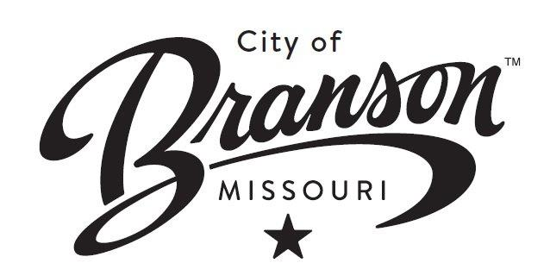
Press Contact:

Mariya Serykh, Comms Manager
417.559.3177
mserykh@bransonmo.gov

Lane Closure at Main St. and Branson Landing Blvd.
April 14-17, 2025

(BRANSON, MO, April 13, 2025) The City of Branson Public Works/Engineering Department will be performing work at the intersection of Main St. and Branson Landing Blvd. for installation of traffic signal equipment beginning Monday, April 14, 2025 from 7:30 a.m. to 5:00 p.m. Work should be complete by Thursday, April 17, 2025.

Traffic control signage will be in place to direct motorists and pedestrians safely through the work zone. Please use caution when traveling through the intersection. Short term lane adjustments and delays can be expected during the performance of the work. Work is weather dependent. Drivers are encouraged to slow down and be mindful of signs and workers in the marked Work Zone.

For questions regarding this work zone, please contact the City of Branson Public Works/Engineering Department at 417-337-8559.

