  SERVICE INTEGRITY ACCOUNTABILITY  OUR MISSION:  Our reason for being is our community; so we hold ourselves to the highest standards in building and maintaining community trust and partnerships. We always strive to enhance our community through a commitment to excellence, compassion, and impartiality in all of our actions.  OUR VISION:  The Branson Police Department will be a source of pride for the community, exemplifying SERVICE, INTEGRITY, AND ACCOUNTABILITY. We want to serve our community and be the area leader in providing superior law enforcement results. We accomplish this through dedication to our values, the community, and each other. |  |  |  |  |  | 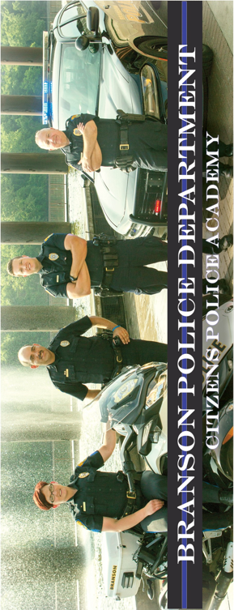
  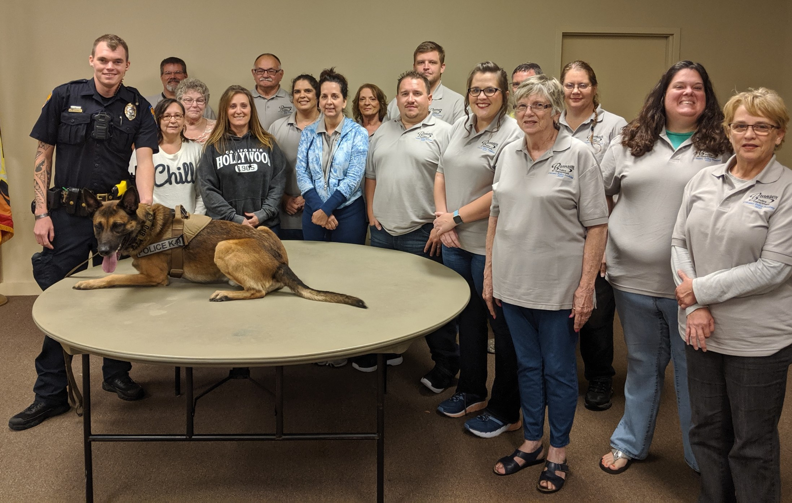
  
  BRANSON POLICE DEPARTMENT
  110 W. MADDUX ST, SUITE #100 BRANSON, MO 65616
  417-334-3300 WWW. BRANSONMO.GOV

Objectives of the  Citizens Police Academy  The objective of this program is to develop a community understanding of the Mission, Values, and Operations of the Police Department. To achieve this goal, the Citizens Police Academy was created to exclusively allow the citizens and business leaders of Branson an opportunity to experience the day-to-day operations of their community’s Police Department.  The academy offers hands-on experiences and insights into the nature of police services in Branson and is designed around a 12-week curriculum meeting once a week in a night class setting.  The program includes classroom training, open discussions, multi-media presentations, demonstrations, and practical hands-on exercises.  Upon completion of the program, students will be able to demonstrate an understanding of the goals, values and operational objectives of the Police Department that serves the community in which they live and work. At the completion of the program, students will be awarded certificates in a graduation ceremony held at the Branson City Hall.  It is the hope of the Branson Police Department that students graduating from the Citizens Police Academy will develop a clear understanding of police services, assist the department in community relations and advocate in support of police-sponsored activities and programs in Branson. |  |  | FALL 2020 ACADEMY  The twelve week program is conducted on consecutive Thursday evenings from 6:00-9:00 pm. The Fall 2020 Citizens Police Academy begins September 3rd and graduates on November 19th.  Course Topics  Administration Organization  Traffic Enforcement  DWI Enforcement  Communications/Dispatch  Patrol Procedures  Judicial Process  Special Investigations & Narcotics  Criminal Investigations  Crime Scene Investigation  Tactical Operations/K-9  Basic First Aid/CPR  Applications must be submitted by:  AUGUST 1, 2020  Mail completed application to:  Branson Police Department  Attn: Officer Darold Donathan  110 W. Maddux, Suite 100  Branson, Missouri 65616 |  |  | CITIZENS POLICE ACADEMY APPLICATION  Name: ____________________________________________  First Middle Last  Date of Birth: _____________________________________  Social Security #: __________________________________  Address: __________________________________________  ___________________________________________________  Phone #: __________________________________________  Email: _____________________________________________  Place of Employment: ______________________________  ____________________________________________________  Occupation: ________________________________________  Driver’s License #: __________________________________  Issuing State: ________  Is your Driver’s License valid? YES NO  Have you ever been arrested for anything other than a traffic offense? YES NO  If YES, explain where, when and disposition:  ___________________________________________________  ___________________________________________________  EMERGENCY CONTACT INFORMATION  Name: ____________________________________________  Phone #: __________________________________________  I certify that all statements made on this application are true and complete. I certify that I am at least 21 years of age and agree to allow the Branson Police Department to conduct a background check prior to my participation in the Citizens Police Academy. I agree and understand that any deliberate misstatement or omission of material facts may disqualify me from attending the Citizens Police Academy. My signature below acknowledges my understanding and agreement with the material provided.  ___________________________________________________  Signature Date

